Site Survey for Sentry-6002 Installation

Company and Site Information
Client/Company Name: | Site Name:
Plant Type:  ☐ Power Generation  ☐ Substation  ☐ Other (specify) | Client Technical Contact:  Tel:  Cell:  Email:
Installation Address: | Installer:
Intended Installation Date:

Battery Information
Battery type/Model: | Capacity: Ah
Bus Voltage: ☐ 120V ☐240V | Battery Number in This String:
Designed Maximum Current: A | Contact BatteryDAQ if this is for Ni-Cad batteries.
Terminal/Post Bolt Size  ☐ 6mm  ☐ 8mm  ☐ 10mm  ☐ Others | 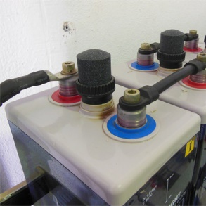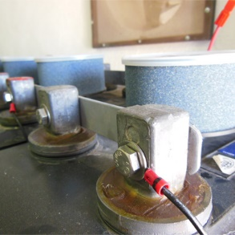
Bus Cable Size: | Number of Cables at Inter-Tier:

Sentry BMS mounting location
Choose one or more mounting options
Location | Description
☐ Inside battery room, wall mounting
☐ Inside battery room, mount on battery rack
☐ Control room next to battery room, wall mounting
☐ Other (specify)

Take Photos (Very Important)
Please attach high resolution photos.
 | Description | Example
Photo-1  ☐ | Show battery overall room  (multiple photos if necessary) | 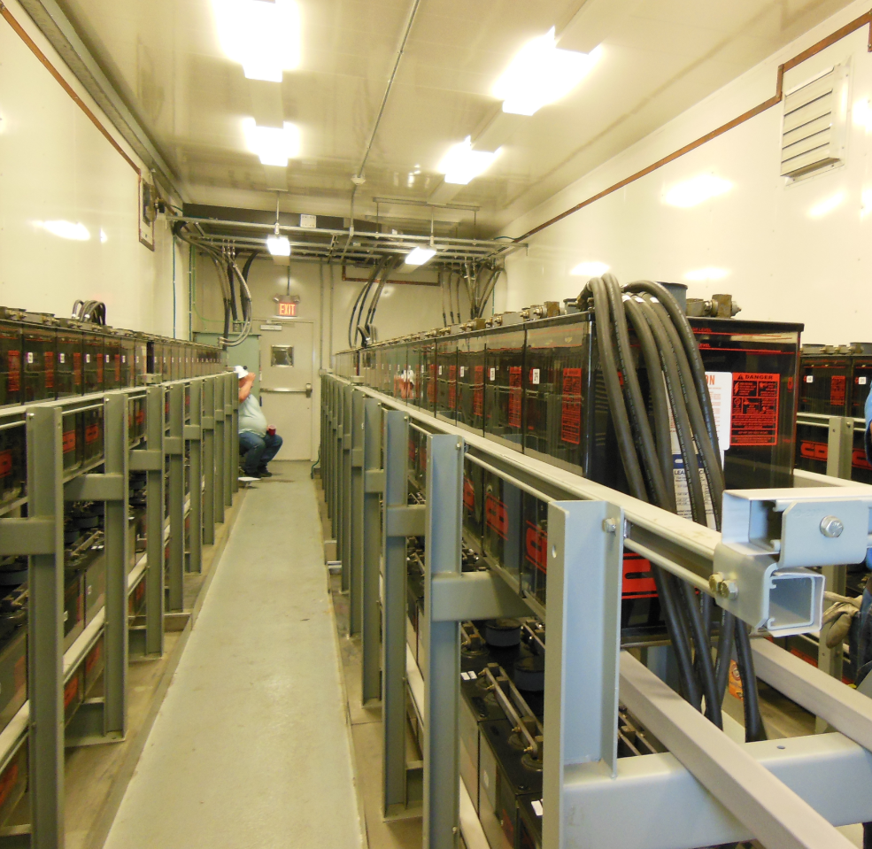
Photo-2  ☐ | Show battery brand/model | 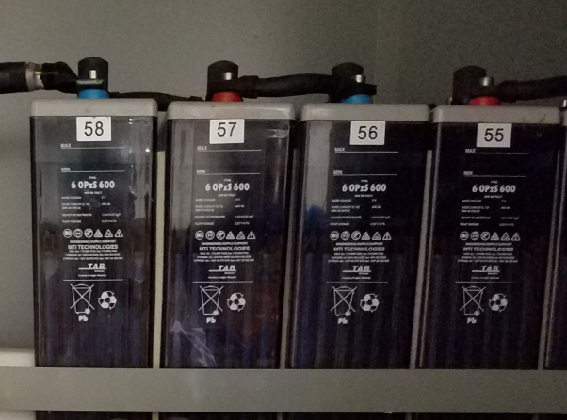
Photo-3  ☐ | Show battery post/terminal and connection bar/cable | 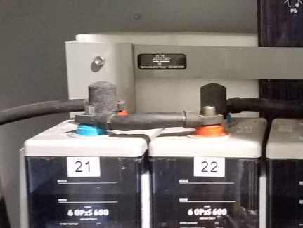
Photo-4  ☐ | Show Positive bus connection | 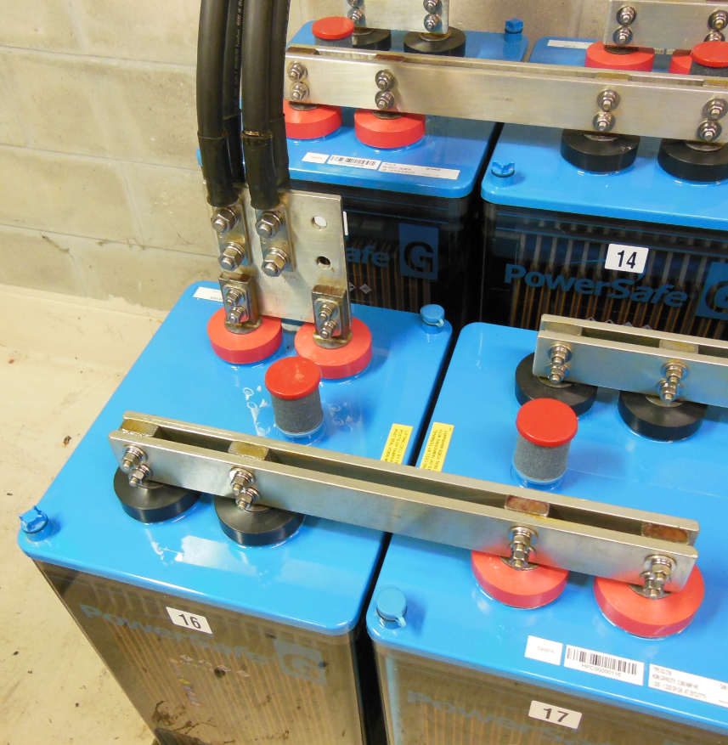
Photo-5  ☐ | Show Negative bus connection | 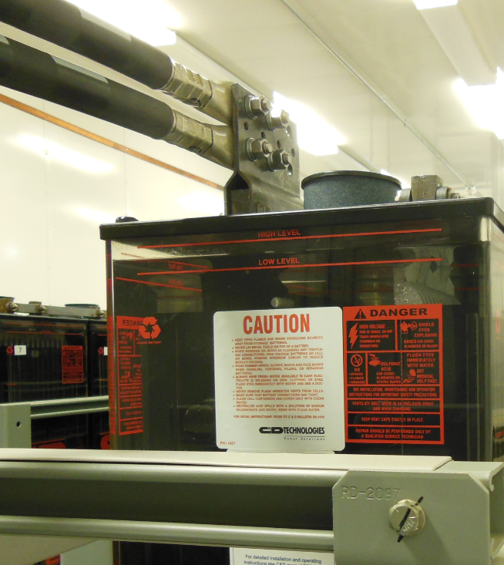
Photo-6  ☐ | Show Inter-Tier connection for choosing correct window size for Current Transducer  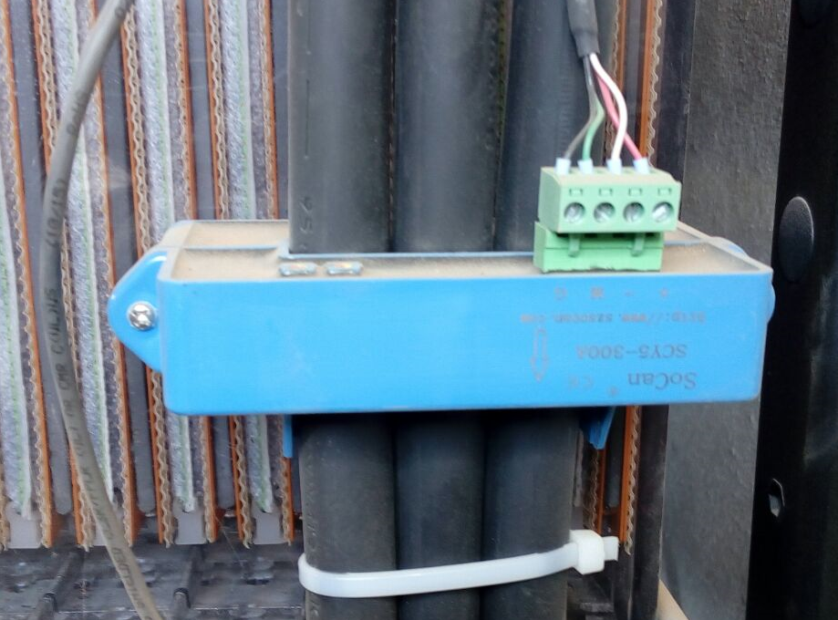 | 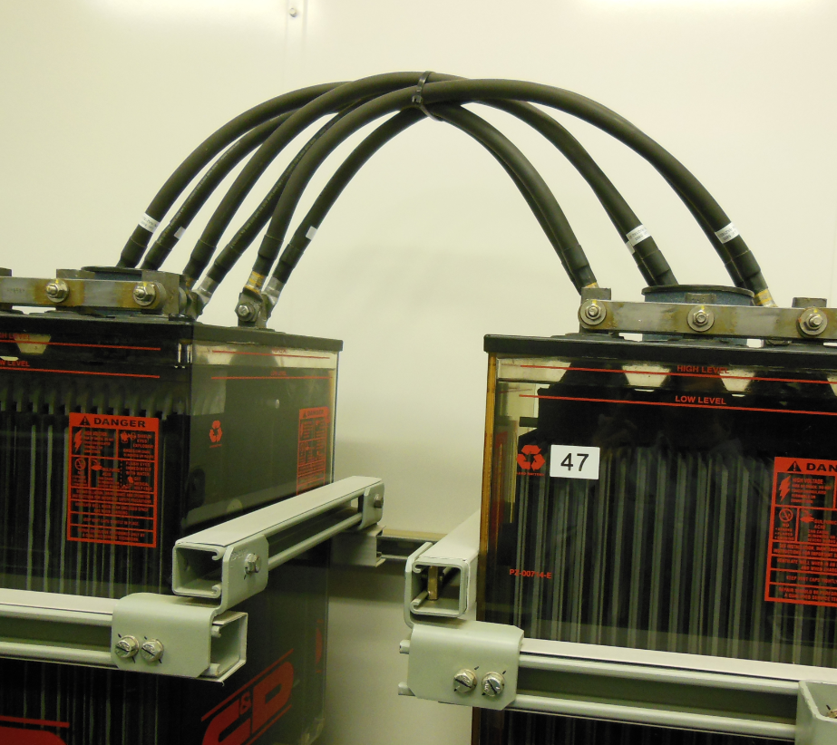
Photo-7  ☐ | Intended BMS mounting location | 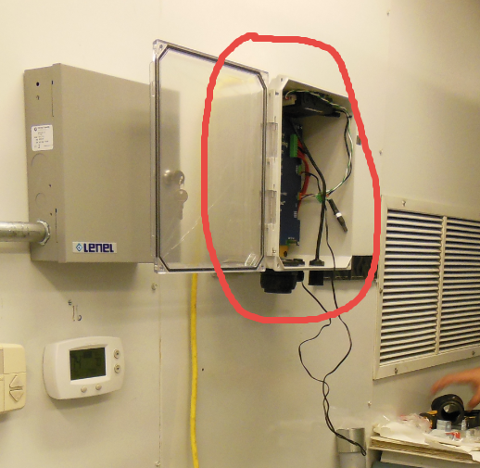
Photo-8  ☐ | Show rack structure for cable tray installation | 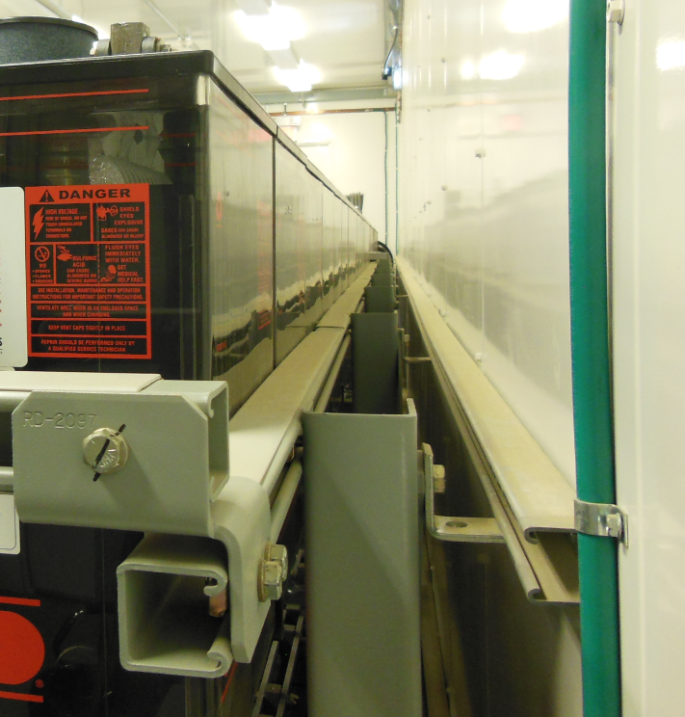

Cable Length Estimation
If the unit is installed inside the battery room [Preferred], on the wall or onto the rack, first identify the best location, then estimate the cable length to reach the farthest battery cell.
When the battery rack is split into multiple sections, consider the extra length to pass through from one section to another. For some construction, it may need to go through the ceiling or floor.
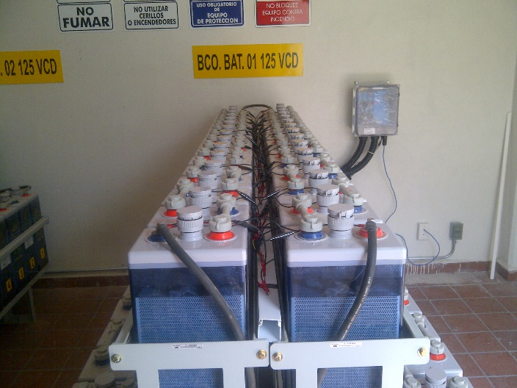 | 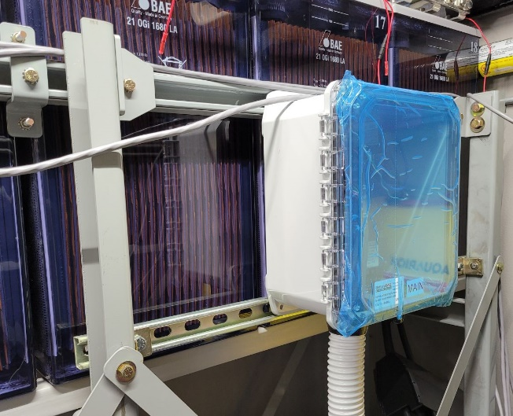
Wall Mounting | Rack Mounting
If the unit is installed in the control room next to battery room, please check the distance and estimate the maximum cable length.
L1(ft) | L2(ft) | L3(ft) | L4(ft) | Total (ft)
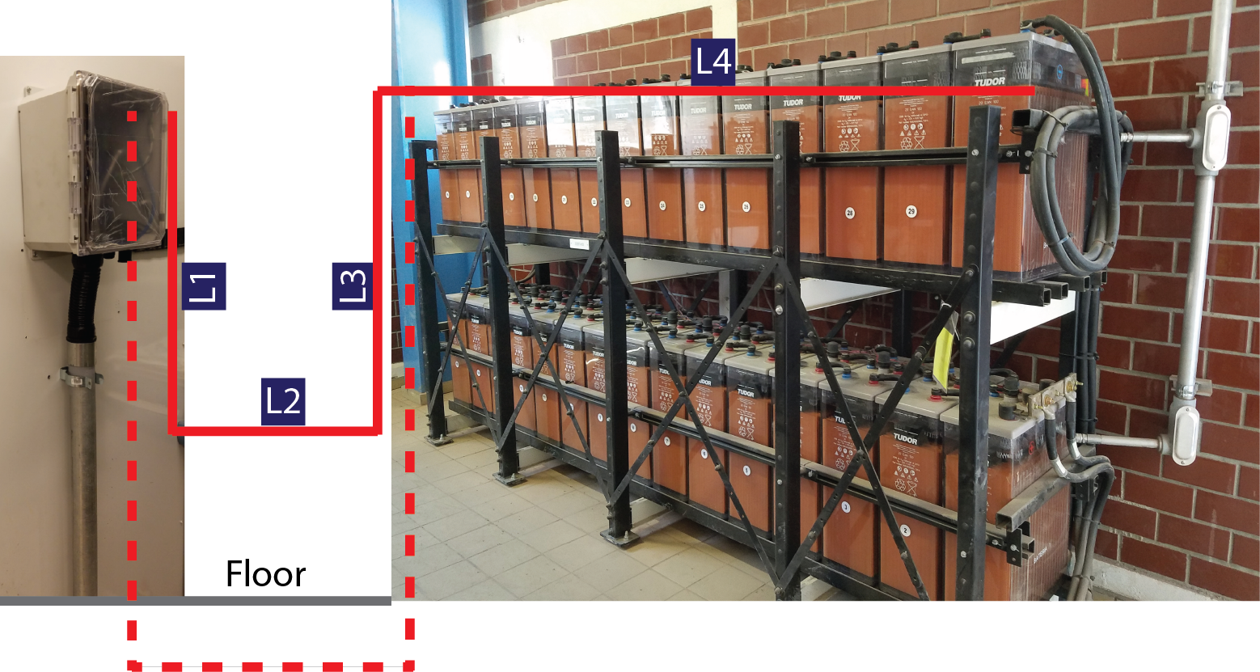
Dashed lines are for going under floor.

Conduit
Confirm with client if any specific conduit is required for wiring.

Network Connection
Discuss with client for available network options.
IoT cellular is a low-cost solution when regular Ethernet is not available. Contact BatteryDAQ for details.
# | Available Connection Options on Site | Check | Description/Client’s preference
1 | Ethernet with assigned static IP | ☐
2 | Fiber connection (Fiber adapter provided by BatteryDAQ) | ☐
3 | IoT Cellular-1 (SIM card provided by BatteryDAQ with annual data fee) | ☐
4 | IoT Cellular-2 (SIM card provided by client) | ☐
5 | Company’s Wi-Fi | ☐
6 | Cellular Router provided by client | ☐
7 | RS485 to SCADA | ☐
8 | Direct Connection between PC and BMS  [Access data, download history, perform load test] | ☐

